Mediation as an organizational competence:
Enabling sustainable practice within paradoxant systems

« Candidats au Prix Roland Calori »

Sébastien Picard* Mar Perezts*

* ESCP-EUROPE, 79 avenue de la République 75543 Paris

Abstract:

The need to act within paradoxical situations has lead managers to develop new skills and devices in order to “muddle [their way] through” (Lindblom 1959). Managers’ survival as individuals within what have been qualified as “paradoxant systems” (Aubert & Gaulejac 1991), depends greatly on their capacity to successfully develop means to cope with them. However, the survival of the organization itself depends on its capacity to integrate this tacit knowledge, in order to “stay afloat” despite changing individuals.
In a recent work, Perezts et al. (2012) explored the importance of this issue and questioned the durability of such organizational forms if they fail to transform an individual ability gained through struggling with paradoxant systems into a durable organizational learning process. However, it is precisely what studies on paradoxes have signaled as impossible (i.e. Hennestad 1990, drawing on Bateson’s original work on paradoxical injunctions).
This paper addresses this question: how to transform an individual capacity into a core competence within the paradoxant organization? We shall build on Perezts et al. (2012)’s analysis where they found that mediation between the conflicting alternatives of the paradox was a successful means to work a way through the paradox from within, instead of working against it, denying it or submitting to choice. Pursuing this, and building on recent developments on paradox theory in organizations and on ethnographic data, we shall strive to address the challenge posed in practice by paradoxant organizations to ensure the development of mediation not only as an individual managerial skill but as a core organizational competence.
We begin by reviewing the literature on organizational paradoxes, “paradoxant systems” and the idea that mediation can constitute a way through the paradox. Second, we develop a theoretical construct of mediation as an organizational competence. Third, we expose the ethnographic method used. We then analyze the case of a Compliance unit in a French Investment bank to illustrate the process of transforming mediation into an organizational competence through situated construction (sensemaking), translation (sensegiving) and clarification (sensekeeping) in order to produce mediation and we outline the conditions for that process. We finally discuss our findings and possible discussion issues, particularly with sensemaking theories in future research.

Key words: Ethics, Mediation, Organizational competence, Paradoxant system, Sensemaking theories
Mediation as an organizational competence:
Enabling sustainable practice within paradoxant systems

Introduction

The need to act within paradoxical situations has lead managers to develop new skills and devices in order to “muddle [their way] through” (Lindblom 1959). Managers’ survival as individuals within what have been qualified as “paradoxant systems” (Aubert & Gaulejac 1991), depends greatly on their capacity to successfully develop means to cope with them. However, the survival of the organization itself depends on its capacity to integrate this tacit knowledge, in order to “stay afloat” despite changing individuals. In a recent work, XXXX et al. (2012) explored the importance of this issue and questioned the durability of such organizational forms if they fail to transform an individual ability gained through struggling with paradoxant systems into a durable organizational learning process. However, it is precisely what studies on paradoxes have signaled as impossible (i.e. Hennestad 1990, drawing on Bateson’s original work on paradoxical injunctions).
In this paper we thus explore if navigating in paradoxant organizations can be something that goes beyond individuals and eventually be a core competence in such organizational form. We shall build on Perezts et al. (2012)’s analysis where the authors found that mediation between the conflicting alternatives of the paradox was a successful means to work a way through the paradox, instead of working against it, denying it or submitting to choice. Pursuing this work and building on recent developments on paradox theory in organizations and on ethnographic data, we shall strive to address the challenge posed in practice by paradoxant organizations to ensure the development of mediation not only as an individual managerial skill but as a core organizational competence.
We begin by reviewing the literature on organizational paradoxes, “paradoxant systems” and the idea that mediation can constitute a way through the paradox. Second, we develop a theoretical construct of mediation as an organizational competence. Third, we expose the ethnographic method used and analyze the case of a Compliance unit in a French Investment bank to illustrate the process of transforming mediation into an organizational competence through situated construction (sensemaking), translation (sensegiving) and clarification (sensekeeping) in order to produce mediation and we outline the conditions for that process. Finally, we discuss the contribution of this study to the sensemaking and organizational competence literatures, and briefly outline an agenda for future research.

Literature review
  - Paradoxes and paradoxant systems
Contradiction and paradoxical dimensions of the organization have been acknowledged as a cliché (Handy 1994) inherent to organization’s nature (Brunsson 1985) and growing complexity (Richardson, 2008; Ethiraj & Levinthal 2009). Therefore, they imply important implications for organizing (Perrow 1972; Perret & Josserand 2003; Solow & Szmerekovsky, 2006) and demand of employees to continuously find new ways of “muddling through” (Lindblom 1959). Indeed, paradox has become a “normal condition” asserted through constant paradoxical injunctions (Bateson et al. 1956; Wagner, 1978 Wittezaele 2008), evolving into “double-bind patterns” (Hennestad 1990:268) which reinforce inherent contradictions and trap individuals within them.
Aubert and Gaulejac (1991) define these as “paradoxant systems”, where attempts to resolve contradictions actually end up reinforcing complexity and the opposition which cannot be resolved through choice since both alternatives must be dealt with. We then face a “having to do both A and B” situation, while knowing A and B to be mutually exclusive. Indeed, paradox theory sustains that competing demands can and should be met simultaneously, without submitting to unsatisfactory choices (Smith & Lewis 2011). This calls for resilient organizations which can find ways to integrate the conflicting elements of the paradox in order to work a way through it (Quinn & Cameron 1988; Clegg, Cuhna & Cuhna 2002; Smith & Lewis 2011). Perezts et al. (2012) addressed this from an ethical perspective, showing that organizational paradoxes can thus turn into ethical paradoxes as well (different from dilemmas which follow an either/or structure), in the need to “serve two masters” simultaneously without choosing one over the other. Such systems of organizing are not rare, and the paradox is often explicitly woven into the organizational design (Perezts et al. 2012) where the conflicting objectives are legitimate and should not be exclusive of one another, but when put together are often incompatible (i.e. pharmaceutical companies’ health/profit conflict, the needs of developing countries vs. global ecological imperatives…). Paradoxes appear as a fruitful lens through which we might approach complex situations (Poole and Van de Ven, 1989; Luscher and Lewis, 2008) and can help to reveal new aspects of organizing.

  - Mediation as way through the paradox
In their study, Perezts et al. (2012) suggest that mediation (Pagès et al. 1979), at the managerial level, is a key element in ensuring effective organizing over time. Mediation concerns the ability of “creating an interface and enacting coherence from within” (Perezts et al 2012). It relies on the manager’s cognitive bricolage ability (tinkering with concepts cf. Levi-Strauss 1962; Bouilloud 2009) to make sense of the present situation and find solutions which are necessarily temporary since based on a paradoxant system that will continue to assert and create more paradoxes. He must then “unveil” the nature of the paradoxical situation to colleagues and subordinates in order to enable action.
Indeed, organizations producing constant paradoxes often rely on managers to solve, on a day-today basis, the problems they face, thus compromising the ability to learn from these situations over the long run (Hennestad 1990). The question then arises: how can a sustainable managerial practice be drawn from and implemented within paradoxant systems?
Perezts et al. (2012) found that paradoxant situations can lead to three types of behavior. 1) Denial and ‘shrunken immobility’ (Argyris 1986) leading to mechanic actions and eventually to burnout. 2) To submit to choice, refusing to acknowledge or ignoring the paradoxical nature of the situation, viewing it as a dilemma or a contingency. 3) To transform opposition into mediation, thus creating an interface to enact coherence from within through a twofold communication strategy, orienting discourses according to whom they are addressing. While this can be perceived as “tricks” in order to survive in the context of ethical pluralism (Pratt and Foreman, 2000) which cannot be resolved by referring to a shared ethos (Stansbury, 2009), it appears as a concrete way to enable action and actually take responsibility in contradictory environments. This mediation process involves situated construction (i.e. the ability to make sense of the specific situation which will require an ad-hoc response instead of an ideal prescription), translation (i.e. speaking to each counterparty in their own logic and terms, and what has been identified as “ambidexterity” (cf. Gibson and Birkinshaw 2004)) and clarification (i.e. the manager doesn’t attempt to actually solve the paradoxical situation, which he cannot, but simply unveil it in order to decide, act and take responsibility).
As the name itself suggests, mediation implies a middle ground positioning, allowing the building of a sustainable organizational practice in contradictory environments where choice among the conflicting alternatives is not an option. Mediation encourages not only drawing from both sides in view of satisfying them, but also as a proactive way to bring them together from within.

Mediation as an organizational competence
At which conditions can mediation become an organizational competence? According to Perezts et al. (2012) a “paradoxant system” implies a new conception of the role of the manager (and hence of his responsibilities). Indeed, the role of a manager would be better understood as analyzing and unveiling the nature of the “paradoxant system” through bricolage. In this perspective, the manager must strive to create an interface and enact coherence from within. However, if bricolage reflects the cognitive effort to integrate several antagonisms and lies in the mediation capacity to make sense, translate and clarify the nature of such a system to allow action, it can hardly constitute a model sustainable over time if it relies on one individual. Organizations should strive to be able to transform the capacity to mediate into a core competence.

  - The nature of organizational competencies
During the 1970s we started to observe a shift in the conceptualization of firms and in the patterns of their internal relationships. Indeed, from a firm that was seeking to canalize its activities through the prescription of tasks, we saw the emergence of a management that tended to promote cooperation, autonomy and responsibility (Lichtenberger, 2003; Parlier, 2003).
Indeed, the word competence finds its root in the latin word competere, « toward a same point » or « trying to obtain with » (Lichtenberger, 2003), which reveals the idea of practical knowledge of how to act in situations and, thus, a dynamic nature (Malgalaive, 1990). However, the variety of definitions of competences emerged because the concept lies at the crossroad of two fields of management science: human resources management and strategic management. While the latter focuses on the strategic dimension of competences at the firm level, the former is more interested by the development and the management of individual competences - or skills in a US understanding -, and with less emphasis on group competences. According to Mack (1995), a skill is an aggregation of knowledge, know-how and practices to efficiently achieve some objectives. Malgalaive (1990) introduces the notion of context by defining individual competence as the dynamic implementation of a set of knowledge, know-how and practice in a given situation with the means at hand. This approach highlights the existence of a situation and the ex post resources necessary to perform a competence. Thus, if a competence is a transformation of knowledge into action (Mandon, 1991), it must include coordinative dimensions between individual behaviors, means and situations. Yet, whatever the definition, all authors recognize that a competence does exist per se and needs to be acquired and improved through learning.
Prahalad & Hamel (1990) distinguish an organizational competence from a resource by the fact that the former does not degrade with its use but, contrary to the latter, grows through learning. Then, the authors define core competence as « the collective learning in the organization, especially how to coordinate diverse production skills and integrate multiple streams of technologies » (1990: 82) and argue that they underline firms’ competitive advantage. Within this perspective, the firm is thus represented as a specific combination of organizational competences which define the firm boundaries (Penrose, 1959; Grant, 1996). However, as Sainty (2001) notes, if core competence theory is a reflection on how to develop competences for competitive advantage, the value that these competences create lies first in the management process (Doz, 1979), rather than in the concepts of knowledge and individual expertise that are coordinated.
One can note that both approaches are reflecting each other through the prism of the coordination ability. Subsequently, it is possible to define a competence as an actuation of a more or less stabilized combination of theoretical knowledge, practical knowledge, know-how and behavior in the efficient carrying out of an action in a given situation, with the resources at hand. This definition has the advantage to emphasize the situated, goal seeking, combinatory and dynamic nature of competencies whatever the level considered. However, we should also recognize that organizational competences, just like individual skills, are developed through learning and need to be maintained because they fade if not used.
This latter points highlights the fact that organizational competencies, or even skills, are always an artifact that can be only apprehended though the measure of a performance. And yet, with the emergence of globalization and the increasing complexity of doing business in fast-paced economies, firms’ performance has become often conditioned to the appropriation of firm’s strategic objectives by groups capable of local self-organization (Floyd & Wooldridge, 2000). In other words, performance is often dependent on others, which might be dependent on the former to lead to the overall performance of the firm. This definitely shifts the focus on the notion of acting together in which the ability of interacting and learning are critical. Therefore the search of management means to produce and share knowledge so as to create collective competences that go beyond the intrinsic cognitive limits leads to differentiate individual skill from organizational competence. The latter puts indeed a strong emphasis on communication, diagnostic, decision, organizing and action in which individuals are the receptacle of information and producers of knowledge for the firm.
Beyond know-how, which can be seen as interchangeable, it is thus the cross fertilization of individual’s initiatives and involvement in their activities that tend to ensure firm’s performance. In that sense managing knowledge appears to be the central concern of modern managers (Sanchez, 2001). However, this distinction between organizational and individual competence has lead to a misunderstanding of how knowledge is integrated. For instance, Grant (1996) argues that the knowledge architecture of a firm is divided according the degree of aggregation of competences. The author distinguishes three levels of integration: an elementary level, which includes skills directly related to operational activities of the firm (e.g. knowledge production), an intermediate level where the expertise is aggregated in functional competence (e.g. marketing), a higher level, with competences involving a wide cross-functional integration that influences the entire organization (the coordination process, decision making). While this division is conceptually useful, it is however an abstraction that finds little empirical resonance because it presumes too much of the role of top and middle managers. Such approaches do not take into account the complex pattern of relationships that cross the entire firm. Indeed, individuals’ intention and effort to coordinate and integrate what works in the execution of their tasks (Levinthal & March, 1981; Narduzzo et al., 2000) are permanent, top-down, and bottom-up but also lateral. These patterns of behaviors can be considered as the empirical manifestation of organizational competence and conceptualized as the cognitive efforts of every organizational actor to understand the causal links that underline their performance. Indeed, organizational actors are often committed to their role, and consequently facing their responsibilities they interact with the environment in a attempt to dispel significant causal ambiguity (Barney, 1991; Lipmann & Rumelt, 1982) - although some always persists and explains why organizational competence can be only apprehended though its performance.

  - The elements of organizational competences
Drawing on the previous part and Lichtenberger (2003), we argue that competences - whether individual or collective - have four dimensions: the general capacity to execute the task, the specific skills of actor(s) (expertise), a legitimacy which is the attribution of a decision power to the individual/group who acts, and finally a commitment to the task. Indeed, the notion of capacity provides a concrete and embodied nature to a competence as it defines the relation between the resources mobilized and the means attributed for a specific task and performance. Yet, a competence is always a combination because at the minimum it needs a certain level of adaptability to perform a task in a given situation. This highlights cognitive abilities that define the level of exploration and assimilation an individual/group is capable of in order to execute the task (Zahra & Georges 2002).
The word competence comes also from the Latin word competentia which draws the right given to an authority to judge and decide in a specific domain. It is an extension to a more collective dimension which embeds the task of an individual/group in a larger collective work. A competence is thus a capacitation, which empowers an individual/group with a sphere of responsibilities to perform a task (expertise). However, it is in fact a legitimacy that results from intense confrontations (Suddaby, 2005) occuring along, but also across, an organization’s hierarchy, and attributes a role that shifts a competence toward a commitment of results rather than a commitment of means.
Finally, the responsibilities attached to a competence render explicit the conditions to execute a task. This in fact highlights the link and the interaction between an individual/group with the organization (Parlier 2003). It is a commitment that lies in a dynamic appropriation of the constraints and opportunities according to the competence’s contribution to the global objective, but also in the horizontal and vertical pattern of cooperation necessary to efficiently carry out objectives in a given situation. That is to put into motion the organization in giving a sense to action through relational capacities (relational know-how, communication, information sharing etc.).

  - Ethics at the heart of the mediation capacity
Building on the theoretical framework developed previously, we suggest that for mediation to be a way to enact coherence, it needs to be approached as an organizational competence in which managers and their subordinates are the receptacle where the different injunctions converge. As Perezts et al. (2012) show, managers involved in “paradoxant systems” face the necessity to engage in the process of reconciling contradictions, thus reframing subjective perceptions of others (Bartunek 1988). The paradox carries the challenge of making sense, and ultimately enacting coherence among the contradictory elements. When these elements involve normative frameworks, conceptions of right and wrong or simply the fact that both underpinning logics are legitimate (right), the organizational paradox often turns into an ethical paradox in terms of inter-situational coherence, revealing the ethical dimension of contradictions. The capacity of enacting coherence within a paradoxant system lies first of all in the cognitive process of bricolage, or ‘tinkering with’ the environment through the actions undertaken and the attempts to make sense of these actions (Smircich & Stubbart, 1985) and to share this sense with all who are concerned (Weick et al. 2005). This perspective implies renewing with the idea that ethics resides in moral subjects (Bowen 1953; Bevan & Corvellec 2007), opposite to more depersonalized approaches focused on corporate social responsibility.
The mediation capacity as an organizational competence lies in the simultaneous production of clues for making sense and justifying the conflicting elements of the ethical paradox. In fine the mediation capacity is a 'practical wisdom' (cf. the empirical approach to ethics based on the Aristotelian notion of ‘phronesis’ and the subsequent virtue ethics approach: e.g. Koehn, 1995; Moore, 2002; Fowers, 2003; Holt 2006) that aims to unveil the “paradoxant system” to actors. Figure 1 shows that action in “paradoxant systems” is dependent on a mediation capacity that mobilizes three kinds of skills: situated construction, translation and clarification. However, the ethical practice underlying the capacity of mediation is certainly moderated by the level of expertise, legitimacy and commitment of the manager and his/her team as we shall show in the case to follow (figure 1).

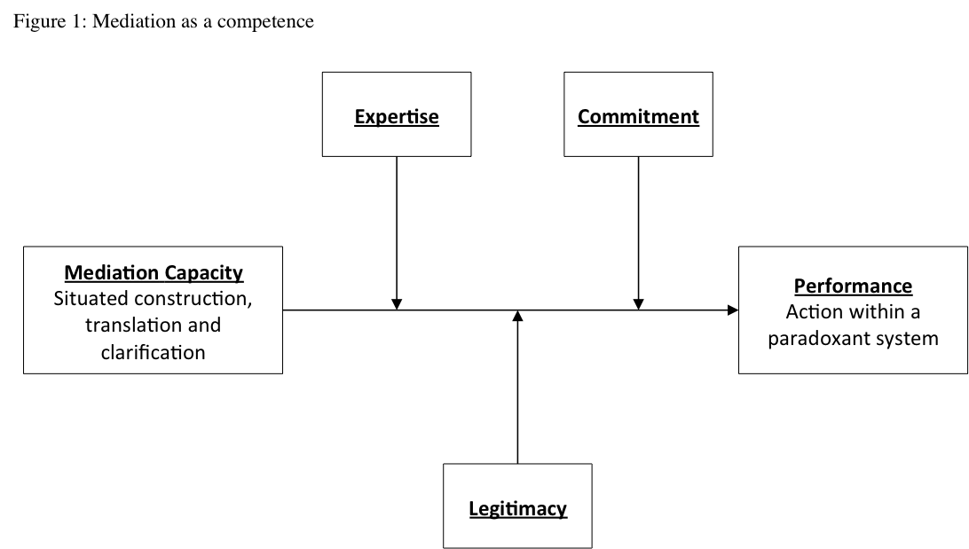
In this paper, we are thus interested in the micro foundations of the mediation capacity developed by individuals in a context of paradoxant systems, and we turn now to illustrate our approach which lies at the crossroad of the fields of organizational contradictions, a sensemaking approach (Gioia et al., 1994; Weick et al. 2005), learning process in paradoxical situations (Hennestad, 1990), and managerial ethics (Perezts et al., 2012), and drawing on the French school on organizational competence (Lichtenberger, 2003).

Data and Method
This paper draws on the ethnographic data (Van Maanen 1988) collected by the first author for her doctoral dissertation and that served as the basis for the forthcoming paper (Perezts et al. 2012). This qualitative ethnographic study was conducted in 2010 within a unit dedicated to Compliance controls (and more specifically Know-Your-Customer and Anti-Money Laundering verifications, hereafter KYC-AML) of the Front Office of a French Investment Bank (hereafter FIB). It was conducted with their informed agreement (Groundwater-Smith & Mockler 2007) which was quite difficult to obtain particularly during the financial crisis, and hence it was done on the basis of confidentiality of the names of the bank and its employees. It alternated periods of participant and non-participant observation eventually even as a trainee within the unit. The whole study was done over nine months, thus allowing the researcher to become part of the environment for a substantial period of time (Rosenthal & Rosnow 1991). These varied perspectives allowed for the collection of rich data in combining several levels of analysis into a single case study (Yin, 1984). This combination earned a diversified insight into various aspects of the subjective meaning the practitioners made of their experience and the way they interpreted ethics with regards to their professional practice and in relation to others’ (Remenyi et al., 1998). Particularly, the internship period was essential in analyzing actual behavior from within, and narratives of real world contexts in regards to ethical problems (Czarniawska, 2004), which were kept in the form of verbatim and rich descriptions (Mintzberg, 1979).
This KYC-AML unit was in charge of approving/refusing potential clients on the grounds of reputation or money laundering and terrorist financing risks for a particular business line in FIB, dealing with international markets. International regulations (such as Basel II, now Basel III, and in Europe the Third European Directive on Money-laundering) compel financial institutions to carry out these checks prior to entering business relationships. We were granted access to observe on a daily basis the process that was undertook in this unit to protect the bank’s reputation and avoid undesirable counterparties through ethnographical note taking (Pettigrew, 1990; Van Maanen, 1988) and “naturally occurring” (Silverman, 2006) qualitative data collection, including access to phone calls, chats, emails and internal documents, business meetings, the yearly global compliance seminar of FIB and an inspection by European regulators. Furthermore, we conducted in situ discussions and semi-structured interviews with organizational actors to deepen some details. For greater reliability, we showed them our journal and notes to get their retrospective feedback and obtained their validation even on our “ongoing stream-of-consciousness commentary about what is happening in the research, involving both observation and analysis” (Eisenhardt 1989, p. 539, referring to Van Maanen, 1988). Drawing on these qualitative event recordings, internal document analysis and discussions, we analyzed the different perceptions the Front Office, the Compliance department and the Top Management had of both teams concerning their comparative efficiency, to render the importance “detailed aspects of corporate relationships” (Remenyi et al. 1998:52). We adopted this practice-based (rather than theory-based) approach focused on the individual, which has already been acknowledged as essential when studying complex organizational phenomena (Argyris, 1964; Perrow, 1972; Ethiraj and Levinthal, 2009) particularly for the specific study of ethics (Nielsen, 2010).
Although the study mainly focused on one specific smaller KYC-AML unit (team B), we were able to compare its processes with that of the second and larger KYC-AML unit (team A) in order to outline the differences of organization, sensemaking and overall effectiveness which we will detail hereafter (Cf. figure 2).
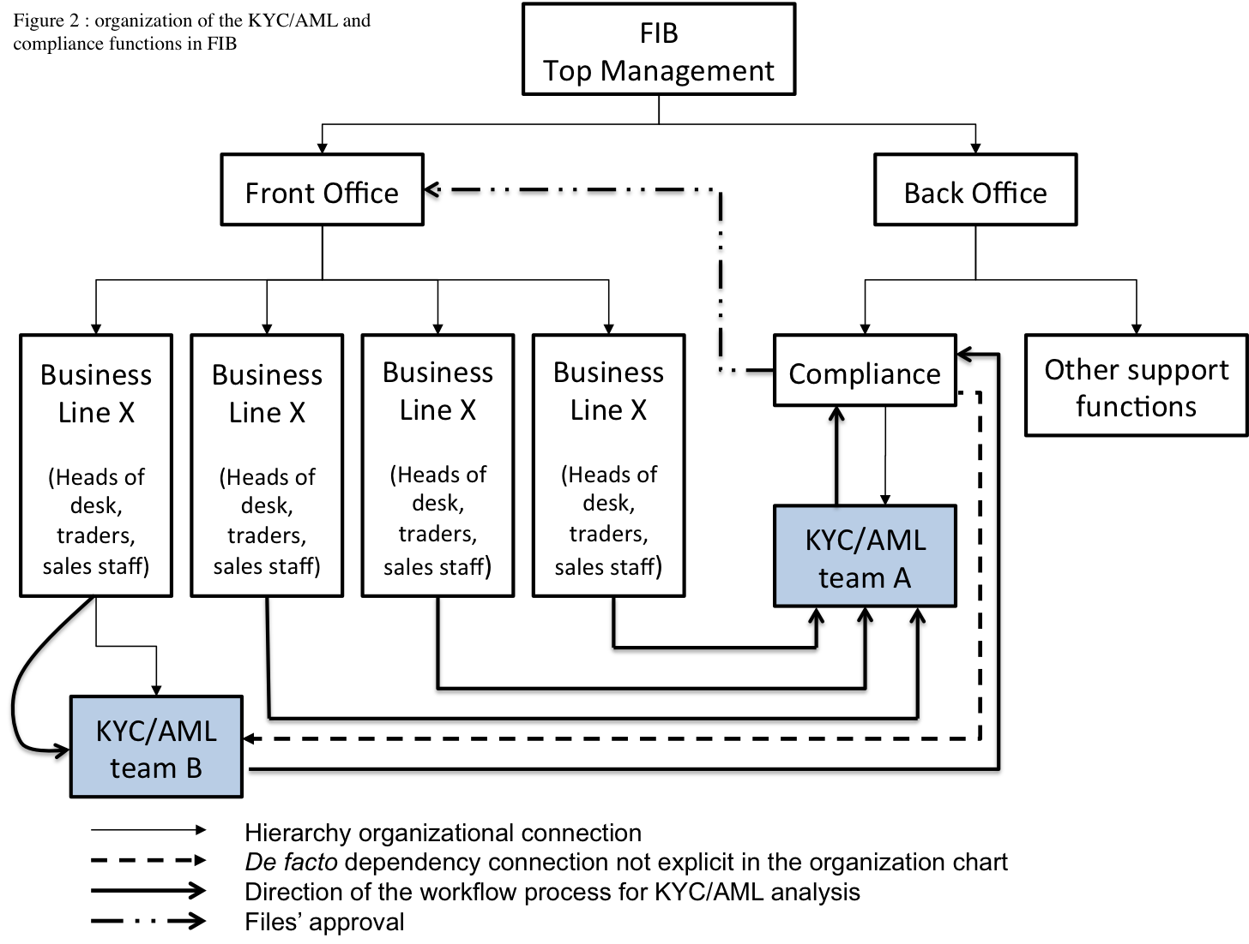

4. Data analysis
The contemporary compliance function in banks is the result of regulatory changes over the past twenty years (Edwards and Wolfe 2004). In particular, the institutionalization of the fight against Money Laundering since the 1989 G7 “Summit of the Arch” led to the creation of the main international regulator in charge of this, the Financial Action Task Force (FATF) (See Williams and Baudin-O’Hayon, 2002). Therefore, by law, over the last couple of decades banks have had to integrate into their ethos, structure and organization the formal role of “watchdogs” or “sentinels” of the financial markets. In Europe, three European Directives on this matter have reinforced this in 1991, 2001 and 2005.
Banks, which have traditionally grown through a commercial logic, have seen policing become one of their core functions (Reiner 1997). As mentioned above, practitioners have often denounced this as an internal organizational contradiction and schizophrenic situation, leading to a series of practical complications, mostly studied through the lens of social studies of finance. Indeed, through their compliance departments, banks have now to decide to recur to whistle blowing or to renounce certain clients and profits if the AML-KYC risk is esteemed too high. The coexistence of both cultures and both somewhat contradictory aims, has lead to engaging in a constant arm-wrestling between the Front Office and the Compliance and Control Departments. The former is considered to embody “true” finance, profit, and creating wealth while the latter, in charge of monitoring and eventually denouncing deviant practices, is viewed as a cost center and a bureaucracy which slows down the business process. In such circumstances, the Compliance Officers (COs) and analysts bear the connotation of internal policemen, whistleblowers and metaphorical gatekeepers in the approval process (Vadera et al., 2009). Moreover, this situation is even more complex in that not only the organization, but also the COs face identity conflicts since they are often confronted to a series of dilemmas (Vandekerckhove and Commers, 2004).
The FIB is a unique example to study, since the compliance function is partly organized within the Front Office. This is an unusual situation, since it is considered essential for the Compliance function to be independent from the Front Office. This unique organizational design (Cf. figure 2) operates the compliance function through two different and parallel channels, to conduct the Know-Your-Customer/Anti-Money-Laundering checks (KYC-AML) (Favarel-Garrigues et al., 2009). Indeed, Team B, contrary to team A and what is usually the case in the banking sector, is an integral part of the Front Office and its connection to the Compliance Department is not explicit. This means that Team B officially depends on the Front Office, where the very people’s interests could seem incompatible with the risk management function that KYC-AML is in charge of ensuring.
Furthermore, we noted that Team B is specifically in charge of the high-risk files, whereas Team A deals mostly with low or medium-low risk files. This definitely poses some eminently ethical questions of independence and efficiency at the level of Team B. Indeed, as one of its analyst says: “all day long, you have to deal with the Sales pressuring you on the phone and by mail with his slogan “business, business, business”, and with Compliance reminding you every two seconds about the mandatory regulations and the risk each deal may imply, which can end up in big trouble for the bank and for you. As a KYC-AML analyst, your personal liability is very high”. Team B is caught between two fires, and must endure constant pressure of its direct hierarchy (the Front Office and its interests) while having to conduct their job with great precision and integrity. Team A enjoys a much more stable positioning, rarely having any direct contact with the Front Office and a much more mechanic and bureaucratic way of dealing the files, according to a “check-list approach”, whereas team B conducted thorough analysis through a “risk based approach”.
However, when comparing Team A and Team B, we are able to notice that team B’s embeddedness appears as a necessary condition to develop effective mediation as being part of the Front Office facilitated dialogue among the Team B's analysts and the Front Officer when dealing with complex files which could not be dealt with through a mechanic check-list approach. The challenge for team B then lied in their capacity to fully understand both the Front Office’s priorities and the Compliance department’s position on the files, which were often incompatible. In fact, Team B developed an integrative communication pattern that helped create an interface among the different actors involved (cf. Figure 3): integrating their own interpretation schemes through sensemaking, speaking to each in their own terms through sensegiving and clarifying the importance of certain priorities in spite of pressures through sensekeeping. In fact, thanks an expertise of investment banking and of regulatory obligations, Team B crystallizes an ethical dimension that enables to mediate between several injunctions on specific high risky files, satisfying both the business priorities and more effective risk management than Team A. Hence, in the words of their manager, team B’s job is to “moralize the Front [office]; keeping an eye on the Sales [department] and imposing responsibility beyond business so they can do clean business”. This objective of doing “clean business is the result of the reframing of both logics that they are supposed to reconcile: the business logic of the Front Office on the one hand, and the risk management priority of the compliance logic on the other.
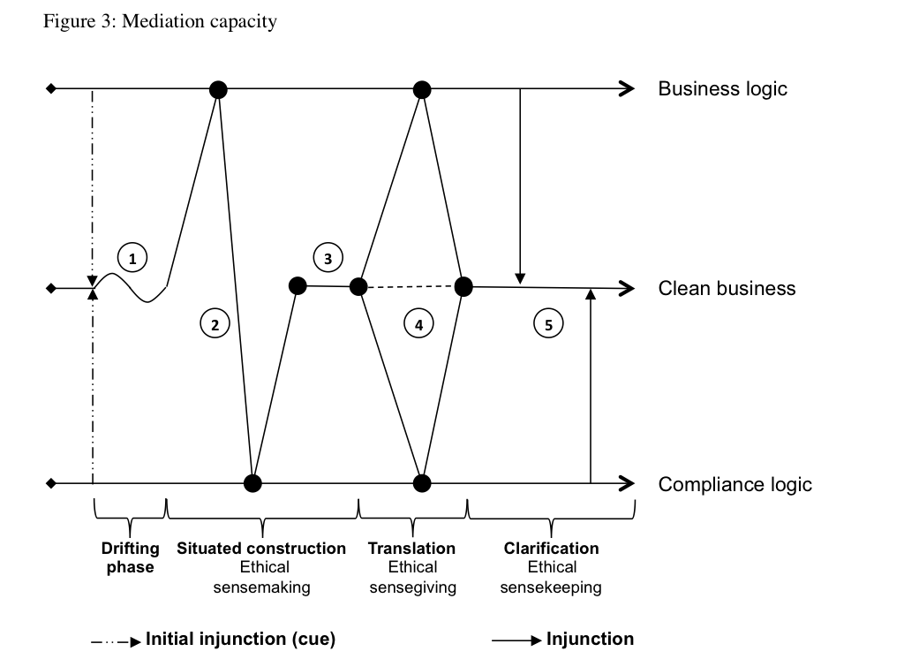

Mediation as a critical organizational competence in paradoxant systems
The creation of team B when team A already existed may seem redundant and as the adding of yet another step in the necessary approval process by Compliance, and in this sector, “money never sleeps”. Time is an essential element of competitive advantage for FIB if they do not want to lose certain deals. We observed that both teams were constantly pressured to some degree by the Front Office to be faster and “less zealous in applying the letter of the law” (email from a Sales person). In addition, the Compliance function is perceived as being an “enemy to business”, “not business oriented” or “these are not market practices” and the traders and sales staff as being the “internal client” of the bank. In this regard, Team B’s direct senior management had little concern for regulatory requirements (wished only to “avoid trouble”) and considered Team B not as collaborators but as service providers. And yet, in team B we see the crystallization of an ethical dimension embedded in the expertise of both investment banking and of regulatory obligations. Indeed, the positioning of the team B shifts the ethical debate from the depersonalized approach of compliance to the engaged approach of embedded ethics. In fact, team B’s members themselves consider ethics as being the core of the complex positioning of their unit, through the oxymoron of “moralizing the Front Office”.

  - Sense-making dimension
Following the workflow, each file is first of all sent by the Front Officer in charge of a given client to either team A or team B, depending on a preliminary categorization of the degree of risk (e. g. team B routinely received files from clients based in tax havens). When either receives a file, the Front Officer in charge of the client had notified other important elements such as the urgency with eventually personal comments to emphasize this. However, in the files dealt with by team B, urgency was systematically high, making it impossible for team B to prioritize the files and organize their work: “Here, everything is ‘urgent’, it’s up to you to sense the true degree of urgency” (Christian, Analyst). Team B is then accustomed to the fact that they must not blindly trust the preliminary categorizations made by the Front Officers who will try to “negotiate everything up to the smallest detail in order to be able to deal quickly” (Yoan, Analyst). Hence, files embed a cue which triggers a process of looking for the gap: the file will be carefully analyzed, often in fact revealing missing or inaccurate information which does not allow for a rapid decision but rather calls for a thorough analysis in view of the doubts revealed. The analyst will then drift during the file’s analysis which will consequently take time (cf. Figure 3, Segment 1), and Front Officers usually react to what they consider “delays” with impatient emails and phone calls to the analyst of team B in charge of the file, or even directly to the manager of team B, and on frequent occasions to the head of the Front Office (team B’s official hierarchy) to complain. Sometimes, the cue may also come from the Compliance department like for example when new regulations are transposed into the internal policies of the bank. Here again, analysts may have an ambiguous phase where he will drift between old and new directives to be implemented. This forces them to reframe the files they are currently working on to make them fit the new framework while reconciling this with the current reality of the Front Office who is not aware of these changes or will not acknowledge them immediately (cf. Figure 3, segment 1).
Theses cues for action, whether coming from one logic or the other, unbalance the situation by highlighting a gap which does not fit clean business since they come in the form of a paradoxical injunction. Sensemaking then appears as a means to render intelligible the situation which is no longer intelligible in order to enable action (Weick 1995): team B will then navigate between both logics in order to reframe the situation by situated construction (Figure 3, segment 2). They will engage in an ethical sensemaking phase which seeks to enact coherence with their clean business objective (cf. Figure 3, segment 3) that includes two conflicting referential frameworks. When it comes to having to act in contradictory environments, we argue that it is not choice, but rather making sense of the paradoxical situation, to apprehend the contradictory logics at stake through a situated construction which will render intelligible and untangle the paradox. Ethics, at the core of the mediation capacity, coupled with the embeddedness of team B’s position, is essential for this situated construction because it allows to map objectively the different elements and thus unveil the paradoxical nature of the situation in order to restore balance.

  - Sense-giving dimension
In being aware of the paradoxical situation through the successful situated construction, team B’s members are empowered to resist the pressures which by definition push towards one of the two other reactions in paradoxant systems: denial and submitting to choice. Denial occurs when the analyst in unable/refuses to identify the paradoxical nature of the situation and will try to avoid it by ignoring it. As Perezts et al. (2012) note, “employees will reduce their own field of action, and make themselves as discrete as possible (Argyris 1964, 1986). They will start doing their job in a bureaucratic way, allowing themselves to be “pushed around” until they explode: “I had never received before the kind of aggressive mails I get every day from Sales in this job. I don’t really know how to answer and when the phone rings, I’m terrified to pick it up”, says Cassandra, a newly recruited KYC-AML analyst. She is typically “caught” by the impossibility to act and to question the paradox, since it “'locks' the ambiguity of the situation” (Hennestad, 1990: 268)”. Likewise, if they submit to choice (i.e. treat the situation as a dilemma) they are then unable to help the others reframe the situation, ultimately ending in enduring conflict because one their “masters” will consider that he is not being considered.
This is why the ethical sensegiving phase within the mediation capacity is essential: team B will help “translate” the opposing priorities in order to fit the frame of reference of the other logic through ambidexterity. This is what Perezts et al. (2012) identify as a “twofold communication strategy, orienting their discourse according to whom they address.” Strongly insisting on their reactivity and the value they add to the business by asserting the preeminence of profit when addressing the Front Office, and rather emphasizing their independence when addressing Compliance.
Sensegiving is “the process of attempting to influence the sensemaking and meaning construction of others towards a preferred redefinition of organizational reality” (Gioia and Chittipeddi 1991: 442), as well as a situated process (Maitlis and Lawrence 2007) that renders necessary a practice perspective. Yet, behind influence (Bean & Hamilton, 2006), ethical sensegiving is rather a support that helps certain groups to understand certain issues. In fact, through ethical sensegiving, team B tries to go against organizational inertia or path dependency mechanisms potentially emerging from both the Front Office and Compliance’s resistance. Indeed, behaviors such as commitment, fear or lack of confidence in ambiguous situations, high pressure to ensure results, routines, and cultural defiance (Carrillo and Gromb 2007), which refuse to or cannot consider the other side of the paradox, often result in inaction, blind spots and self reinforcing mechanisms and narratives for self-sustainment (Geiger and Antonacopoulou 2009) which is particularly among strong communities of practice like the Front Officer and Compliance Officers. We could observe this sort of self-sustaining reaction in Team A, which had difficulty engaging in constructive dialogue with the Front Office, partly because of their lack of expertise in technical issues. On the other hand, the dynamic nature of Team B’s risk-based approach enabled the reconciliation of both logics and the enactment of Figure 3’s segment 4 because of the twofold communication.

  - Sense-keeping dimension
Finally, there is a sensekeeping phase. Once team B has worked to speak to each logic in its own terms and justify the position they adopt in segment 4 of Figure 3, their job is to hold fast to their objective of what they have reframed as “clean business” by resisting the continuous injunctions from both logics which might continue to attempt to pull the situation towards their respective frameworks, or the time they themselves make sense of the situation. Indeed, sensemaking occurs essentially through dialogue in which the nature of the dialogue and words carry meanings and environmental cues. Sensekeeping then does not imply inaction, but rather, when facing sensemaking process of both Front Office and/or Compliance Department, holding fast to the outcome of the situated construction (Segment 3) through the justifying power of clarification in order to provide stability through this mediation capacity. In fact, it is materialized through constant reassertions of their “clean business objective”, as the manager of team B repeats to his team on a daily basis in order to ensure the collective, enacted and ongoing elaboration of this identity as a ontological anchor so as not to be lost in a paradoxant system and allowing action and the business to go on.
This sensekeeping is also what ultimately allows for the possibility of a double loop learning (Argyris and Schon 1978) from the situation, and constituting the evolution of team B’s referential identity in the future. Indeed, Weick’s (2005 p. 409) interpretation of Mills (2003, p.23) indicates that sensemaking is the “primary site where meanings materialize that inform and constrain identity and action”. By keeping sense of what was constructed in previous phases of the mediation capacity and then collectively evaluating the outcome, team B was able to engage in a dynamic interplay that promoted endogenous change and resilience (Howard-Grenville, 2005).

  - Embeddedness dimension
Being part of the Front Office puts team B in an ideal position to promote clean business, which would otherwise be very difficult from the Compliance department, which is too far away and disconnected from the daily reality of the business. Indeed, Team B was created by the FIB’s top management following a suggestion of the Compliance Officer, in order to improve the quality of their analysis: team B is a specialized unit whose expertise in financial market practices, products and procedures enables them to have a much greater understanding of the financial technicalities of the transactions than team A, less trained in certain aspects and having a more “check-list approach”. This gives a legitimate power to Team B to interact and, at least, be listened to by both the Front Office and the Compliance Department. But, in fact, team B managed to be an interface which actually speeds up the process, since they are able to quickly seize the complexity and details of the high risk files, and although Compliance must still approve them, their decision is aided by the depth of the analysis procured by Team B’s expertise and their translation ability. In average, a comparative study of both teams of the 2009 files showed that Team B was three times faster than team A for the low-risk files, and 20% faster on the high risk files which demanded in-depth analysis of complex situations, and which constituted only a marginal part of team A's job while being most of the files analyzed by team B. This performance greatly contributed to legitimate team B in the eyes of the senior management of the Front Office and strongly facilitated dialogue among team B's analysts and the Front Officers when dealing with complex files requiring further analysis.
Indeed, being part of the Front Office pushed team B’s members to acquire knowledge so as to understand better the business logic of their “beholder”. This resulted in a ‘technical’ ambidexterity that helped to create an interface among the different actors in the game. As the manager of team B said: “Despite high pressures, […] I completely trust my team’s ‘instincts’. They know how to be diplomatic with the Sales while being good at their risk analysis work, which is not an easy task”. By integrating each interpretation schemes and speaking to them in their own terms, team B was recognized as expert who allowed for a quicker response in the decision making process on the high risk files, without engaging in unacceptable risks ultimately ending in illegal actions like money laundering.
Yet, from an ethical viewpoint, regulators were concerned about this organizational setting since they fear team B will be unable to maintain objectivity and independence from the Front Office and may “become too friendly with the Front”. During our study, team B underwent an inspection in this respect by the FSA (Financial Services Authority – British regulator). However, team B was greatly supported during the inspection by the Head of Compliance, who not only guaranteed the FSA that they were independent and professional, but proved it through a series of files that had been analyzed and refused by team B while having been greatly pressured to approve them. This commitment to clean business is not a surprise for the Head of Compliance: Team B’s manager has been part of the compliance team since the beginning, and has shaped the growing staff to be entirely trustworthy from an ethical perspective. Rigor and integrity in conducting clean business is certainly the result of having a surprisingly stoic resistance to pressures which definitely lies in working efficiently together.

To sum up, the success of team B in pursuing clean business emerged also from its embedded setting: (1) the organizational decision to place team B within the Front Office came from the top management of FIB (legitimacy), (2) the recognition of a constantly developed expertise from both parties (business and compliance) and (3) a strong commitment of team B’s member to speeds up the overall process in pursuing both business and ensure risk management.

Discussion
Figure 3 explicits how Team B is able to work a way through this situation by unveiling the paradoxant system thanks to a mediation competence which lies in an integration effort to dispel the ambiguities of the contradictory injunctions of the business logic on the one side and the compliance logic on the other (that serve as referential anchors). Mediation is thus achieved through a cognitive and discursive process leading to the reframing of these imperatives towards building what the actors themselves call “clean business”. Yet this mediation becomes a full competence in the sense that it has been a collective negotiation in which embeddedness (expertise, legitimacy, commitment) played a significant role.
Our paper states that mediation is a process of situated construction, translation and clarification. However, we should note that this is a utopist view of how such a capacity comes about. In the empiric world, it is not as simple and each step might overlap or even not happen at all. Such a pattern is in fact useful to understand the micro foundations of what the mediation capacity is about and allows a dialogue with other academic work. For instance, we drew from the sense-making theories (sense-making & sense-giving) as they underlie how organizational actors can render intelligible a disruptive situation in order to enable action (Weick et al., 2005). While these approaches have been largely mobilized to show how change or inertia occur (Daft & Weick, 1984; Foldy et al, 2008; Gioia et al., 1994), our case on paradoxant systems contributes to this literature in two ways. First, it is assumed in sense-making theories that a story of what is going on becomes plausible (and selected) because it resonates with shared meaning, or because there is consensual adequacy to produce organized actions (Brown et al., 2008; Louis, 1980; Pfeffer, 1981; Weick, 1995; Weick et al., 2005). However, in the case of mediation, we show that individuals make sense of the environment not with their dominant logic (Bettis and Prahalad, 1995) but by voluntarily adopting several logics. We also show how ethics, as practical wisdom in action and cognitive ambidexterity are of critical importance in such settings. This calls for further study to better understand this phenomenon. Second, we introduced the notion of sense-keeping as being a potential dimension of the sense-making process.
The word itself is quite new and has made a couple of rare appearances in the literature, mainly as a timid intuition, rather than a structured concept. For instance, Heifetz and Linsky (2002) argue that keeping a sense of one’s essential personal identity is key to weathering the storms of leadership. Zwizje-Koning and de Jong (2008) observe that when employees experience “critical incidents”, they would only consider events which fitted their original frame of reference through “sense-keeping”: “respondents seek events that fit existing values” (2008: 2, 16).
Sensekeeping arises as a counterintuitive notion and thus constitutes a gap in the literature of sensemaking. We sustain that sensekeeping doesn’t exactly correspond to a “failure of imagination” (Weick 2005) but can be apprehended in a positive way, in and for itself, instead of only negatively as a lack of something, a missed potential or a failure to innovate. We define sensekeeping as a voluntary and intentional behavior to maintain a specific sense while opposing tendencies call for change. Individuals act in such a way because for, at least, two reasons: (1) individuals’ social identity, and thus their social survival, is at risk; (2) those individuals have gone through the process of reframing conflicting positions and must now guard them. This cognitive process lies in the search of environmental cues allowing keeping sense can be qualified as a foresighted counterfactual process and may open a new research agenda in the sensemaking literature.

Conclusion
As our paper attempted to illustrate, mediation is merely built on the strength of commitment to action within a constantly evolving organization, on the capacity to fit into and shape a pertinent pattern of relationship through the mobilization of actors and on the quality of its outcome. In that sense, no distinction can be made between individual and organizational competence since one defines the other. Mediation is therefore not natural. Indeed, it is the complex pattern of interactions that will define and legitimate what is the good performance to achieve a task. In other words, I am competent because my peers recognize my performance as the right thing to do. Moreover, besides the fact that my performance depends on the quality of the resources initially needed, which often depend on others, it is my peers who define the threshold of good performance. Legitimacy and expertise emerge always from the distinctiveness of and from the commitment to certain characteristics of a collective compared to another one. Competence is thus a social construction that renders here meaningless the distinction between the individual and the organizational competence.
However, a mediation competence can only be developed by assuming the paradoxant system that solicits it and focuses on really ‘inhabiting’ the moral space and shaping it (Jensen et al. 2009). It is its very nature. Thus, the challenge for an organization to work an effective way through the paradox is also to make available the necessary support to enable organizational members to share knowledge allowing them to overcome their cognitive limitations and intrinsic value. The development of a competence of mediation will depend thus of the existence (or creation) of an organizational atmosphere oriented to the solving of problem and encouraging collaboration, of the necessary authority associated to the role of the competence beholder, but also to define the appropriate level of responsibilities and reward according the criticality of the outcome, to build trust in people and to increase the feeling of being part of collective objectives.

A mediation capacity would thus become an organizational competence under the development of explicit norms, socially constructed and sustained through multiple ‘identificating’ exchanges between stakeholders. This puts up front the plurality of perspectives, expectations and constraints around the division of responsibilities. Yet, mediation as a reflection of our time will be never stabilized. As Bazin (2011) would surely agree, it is rather an on-going flow knowledge, know-how and life skills, institutionalized for some, being institutionalized and deinstitutionalized for others, In fact, like any competences.

References
Argyris, C. (1964), Integrating the individual and the organization, New York: Wiley.
Argyris, C. (1986), Reinforcing Organizational Defensive Routines: An Unintended Human Resources Activity, Human Resource Management, 25, 541-555.
Argyris, C. & D. Schon (1978), Organizational learning: a theory of action perspective, Mass: Addison Wesley.
Aubert, N. & V. de Gaulejac, (1991), Le Coût de l’Excellence, Paris: Le Seuil.
Bartunek, J. (1988), The dynamics of personal and organizational reframing, in R. Quinn & K. Cameron, Paradox and transformation: towards a theory of change in organization and management, Cambridge: Ballinger, 137-162.
Bateson, G., D. Jackson, J. Haley & J. Weakland (1956), Towards a theory of schizophrenia, Behavioral Science, 1, 251-264.
Barney, J. B. (1991), Firm resources and sustained competitive advantage. Journal of Management , 17, 99-120.
Bazin, Y. (2011), L’institutionnalisation des pratiques organisationnelles, le cas du diagnostic en psychiatrie. Unpublished Thesis: CNAM
Bean, C.J. & F. E. Hamilton (2006), Leader framing and follower sensemaking: Response to downsizing in the brave new workplace, Human Relations, 59, 321-349
Bettis, R. A. & C. K. Prahalad (1995), The Dominant Logic: Retrospective and Extension. Strategic Management Journal, 16, 5-14
Bevan, D. & H. Corvellec (2007), The impossibility of corporate ethics: for a Levinasian approach to managerial ethics, Business Ethics: a European Review, 16, 208-219.
Bouilloud, J.P. (2009), Devenir Sociologue, Toulouse: Erès
Bowen, H.R. (1953), Social Responsibilities of the Businessman, New York: Harper & Row.
Brown, A. D., P. Stackey & J. Nandhakumar (2008), Making sense of sensemaking narratives, Human Relations, 61, 1035–1062
Brunsson, N. (1985), The Irrational Organization, Chichester: John Wiley and Sons.
Carrillo, J.D. & D. Gromb (2007), Cultural Inertia and Uniformity in Organizations, Journal of Law, Economics, and Organization, 23:743-771.
Clegg, S.R., J. Vieira da Cunha & M. Pina e Cunha (2002), Management Paradoxes: A Relational View. Human Relations, 55, 483–503
Czarniawska, B. (2004), Narratives in Social Science Research. London: Sage.
Daft, R. L. & K. E. Weick (1984), Toward a Model of Organizations as Interpretation Systems, Academy of Management Review, 9, 284-295.
Doz, Y. (1979), Government Policies and Global Industries, Cambridge: Harvard Business School Press.
Edwards, J. & S. Wolfe (2004), The compliance function in Banks. Journal of Financial Regulation & Compliance, 12, 216-224.
Eisenhardt, K. M. (1989), Building theories from case study research, Academy of Management Review, 14, 532-550.
Ethiraj, S.K. & D. Levinthal (2009), Hoping for A to Z While Rewarding Only A: Complex Organizations and Multiple Goals, Organization Science, 20, 4-21.
Favarel-Guarrigues, G., P. Lascoumes & T. Godefroy (2009), Les Sentinelles de l’argent sale: les banques aux prises avec l’antiblanchiment, Paris: La Découverte.
Floyd, S. W. & B. Wooldridge (2000), Building Strategy from the Middle: Reconceptualizating Strategy Process. Thousand Oaks: Sage.
Fowers, B.J. (2003), Reason and Human finitude: in praise of practical wisdom, American Behavioral Scientist, 47, 415-426.
Foldy, E.G., L. Goldman & S. Ospina (2008), Sensegiving and the role of cognitive shifts in the work of leadership. Leadership Quarterly, 19, 514-529
Geiger, D. & E. Antonacopoulou (2009), Narratives and organizational dynamics: exploring blind spots and organizational inertia”, Journal of Applied Behavioural Science, 45, 411-436.
Gibson, C. & J. Birkinshaw (2004), The antecedents, consequences and mediating role of organizational ambidexterity, Academy of Management Journal, 47, 209-226
Gioia, D. A. & K. Chittipeddi (1991), Sensemaking and sensegiving in strategic change initiation, Strategic Management Journal, 12: 433-448
Gioia, D. A., J. B. Thomas, S. M. Clark & K. Chittipeddi (1994), Symbolism and strategic change in academia: The dynamics of sensemaking and influence, Organization Science, 5, 363-383
Grant, R. M. (1996), Toward a knowledge-based theory of the firm, Strategic Management Journal, 17, 109-122.
Groundwater-Smith, S. & N. Mockler, (2007), Ethics in practitioner research: an issue of quality, Research Papers in Education, 22, 199-211.
Handy, C. (1994): The Age of Paradox, Cambridge: Harvard Business School Press.
Heifetz, R.A. & M. Linsky (2002), Leadership on the line: staying alive through the dangers of leading, Cambridge: Harvard Business School Press.
Hennestad, B. W. (1990), The symbolic impact of double bind leadership: Double bind and the dynamics of organizational culture, Journal of Management Studies, 27, 265–280.
Holt, R. (2006), Principles and practice: rhetoric and the moral character of managers, Human Relations, 59, 91-105.
Howard-Grenville, J. A (2005), The persistence of flexible organizational routines: the role of agency and organizational context. Organization Science. 16, 618-636.
Jensen, T., J. Sandström & S. Helin (2009), Corporate codes of ethics and bending of moral space, Organization, 16, 529-545.
Koehn, D. (1995), A role for virtue ethics in the analysis of business practice, Business Ethics Quarterly, 5, 533-539.
Lévi-Strauss, C. (1962), La Pensée Sauvage, Paris: Plon
Levinthal, D. & J. G. March (1991), A model of Adaptive organizational search, Journal of Economic and Organization, 2, 307-333
Lichtenberger, Y. (2003), La gestion des compétences: une nouvelle régulation du marché du travail, in J. Allouche, Encyclopédie des Ressources Humaines, Paris: Vuibert, 143-152.
Lindblom, C.E. (1959), The Science of 'Muddling Through’, Public Administration Review, 19, 79–88.
Lipmanti, S. A. and R. P. Rumelt (1982), Uncertain imitability: An analysis of interfirm differences in efficiency under competition, Bell Journal of Economics, 13, 418-438
Louis, M. (1980), Surprise and sensemaking: What newcomers experience in entering unfamiliar organizational settings. Administrative Science Quarterly, 25, 226-251
Luscher, L. & M. W. Lewis (2008), Organizational change and managerial sensemaking: working through paradox, Academy of Management Journal, 51, 221-240.
Mack M. (1995), L’organisation apprenante comme système de transformation de la connaissance en valeur, Revue Française de Gestion, Septembre-Octobre, 43-48.
Maitlis, S. & T. B. Lawrence (2007), Triggers and enablers of sensegiving in organizations, Academy of Management Journal, 50, 57-84.
Malgalaive G. (1990), Enseigner à des adultes, Paris: PUF.
Mandon, N. (1991), Analyser des emplois et gestion anticipé des compétences, Céreq Bref, Septembre, 57.
Mills, J. H. (2003), Making sense of Organizational Change, London: Routledge, London.
Mintzberg, H. (1979), An emerging strategy of « direct » research, Administrative Science Quarterly, 24, 580-589.
Moore, G. (2002), On the implications of the Practice-Institution Distinction: MacIntyre and the application of modern virtue to business, Business Ethics Quarterly, 12, 19-32.
Narduzzo, A., E. Rocco & M. Warglien (2000), Talking about routines in the field: The emergence of organizational capabilities in a new cellular phone network company, in G. Dosi, R. R. Nelson & S. G. Winter, The Nature and Dynamics of Organizational Capabilities, New York: Oxford University Press, 27–50
Nielsen, R. P. (2010), Practitioner-based theory building in organizational ethics, Journal of Business Ethics, 93, 401-406
Pagès, M., M. Bonetti, V. de Gaulejac & D. Descendre, D. (1979), L’emprise de l’organisation. Paris: Desclée De Brouwer.
Parlier, M. (2003), Qualification et competence, in J. Allouche, Encyclopédie des Ressources Humaines (pp. 153-166), Paris: Vuibert
Penrose, E. T. (1959), The Theory of the Growth of the Firm, New York: John Wiley.
Perezts, M., J.-B. Bouilloud & V. de Gaulejac (2012). Serving two Masters: the contradictory organization as an ethical challenge for managerial responsibility, Journal of Business Ethics, published online: 25/01/2012
Perret, V. & E. Josserand (2003), Le Paradoxe: penser et gérer autrement les organisations, Paris: Ellipses.
Perrow, C. (1972), Complex Organizations, New-York: McGraw Hill-Random House.
Pettigrew, A.M. (1990), Longitudinal field research on change: theory and practice, Organization Science, 3, 267-292.
Pfeffer, J. (1981), Management as symbolic action: The creation and maintenance of organizational paradigms, in L.L. Cummings & B.M. Staw, Research in organizational behavior, Greenwich: JAI Press, 1–52
Poole, M. S. & A. H. van de Ven (1989), Using Paradox to Build Management and Organization Theories, Academy of Management Review, 14, 562-578
Prahalad, C. K. & G. Hamel (1990), The Core Competence of the Corporation, Harvard Business Review, 68, 79-91.
Pratt, M. G. & P. O. Foreman, P. O. (2000), Classifying managerial responses to multiple organizational identities, Academy of Management Review, 25, 18–42.
Quinn, R. & K. Cameron, K. (1988) Paradox and transformation: towards a theory of change in organization and management, Cambridge: Ballinger.
Remenyi, D., B. Williams, A. Money & E. Schwartz (1998), Doing Research in Business and Management, London: Sage.
Reiner, R. (1997), Policing and the police, in: M. Maguire & R. Reiner, The Oxford Handbook of Criminology, Oxford: Clarendon Press, 997-1049.
Richardson, K. A. (2008), Managing Complex Organizations: Complexity Thinking and the Science and Art of Management, E:CO, 10, 13-26
Rosenthal, R. & R. L. Rosnow (1991), Essentials of Behavioral Research: methods and data analysis, New York: McGraw Hill.
Sainty, F. (2001) Mutuelles de santé et nouveaux contextes d’action: une approche par le modèle ressources – compétences, Unpublished Thesis: Université de Nice Sophia-Antipolis
Sanchez, R. (2001), Managing knowledge into competences: The five learning cycles of the competent organization, in R. Sanchez, Knowledge Management and Organizational Competence, Oxford: Oxford University Press, 3-37
Silverman, D. (2006), Interpreting Qualitative Data, London: Sage.
Smircich, L. & C. Stubbart (1985), Strategic Management in an Enacted World, Academy of Management Review, 10, 724-736.
Smith W. K. & M. W. Lewis (2011), Towards a theory of paradox: a dynamic equilibrium model of organizing, Academy of Management Review, 36, 381-403.
Solow, D. & J. G. Szmerekovsky (2006), The role of leadership: what management science can give back to the study of complex systems, E:CO, 8, 52-60
Stansbury, J. (2009), Reasoned moral agreement: applying discourse ethics within organizations, Business Ethics Quarterly, 19, 33-56.
Suddaby, R. (2005), Rhetorical Strategies of Legitimacy. Administrative Science Quarterly, 50, 35-67.
Vadera, A. K., R. V. Aguilera & B. C. Brianna (2009), Making sense of whistle-blowing’s antecedents: learning from research on identity and ethics programs, Business Ethics Quarterly, 19, 553-586
Van Maanen, J. (1988), Tales of the field: on writing ethnography, Chicago: University of Chicago Press.
Vandekerckhove, W. & M. S. R. Commers (2004), Whistle blowing and rational loyalty. Journal of Business Ethics, 53: 225-233.
Wagner, J. A. III (1978), The Organizational double-bind: toward an understanding of rationality and its complement, Academy of Management Review, 3, 786-795.
Weick, K. E. (1995), Sensemaking in Organizations. London: Sage Publications
Weick, K. E. (2005), Organizing and failures of imagination, International Public Management Journal, 8, 425-438
Weick, K. E., D. Obstfeld & K. M. Sutcliffe (2005), Organizing and the process of sensemaking, Organization Science, 16, 409-421.
Williams, P. & G. Baudin-O'Hayon (2002), Global Governance, transnational organized crime and money laundering, in: A. McGrew & D. Held, Governing globalization, Cambridge: Polity Press, 127-144.
Wittezaele, J. J. (2008), La Double Contrainte. L'héritage des paradoxes de Bateson en Sciences Humaines, Bruxelles: De Boeck.
Yin, R. K. (1984), Case Study Research: Designs and Methods. California: Sage Publications.
Zahra, S. A. & G. George (2002), Absorptive Capacity: A Review, Reconceptualization, and Extension, Academy of Management Review, 27, 185-203.
Zwizje-Koning, K. & M. De Jong (2008), Making sense of experiences: sensemaking processes following critical communication events. Conference paper for the International Communication Association.

